**Post-course report form**

**Name: Emma Leather**

**Bursary applied for: International Bursary**

**Title of course attended or Project details: IFSSH and IFSHT Triennial Conference Washing DC:**

**Date: 25TH March-28th March 2025**

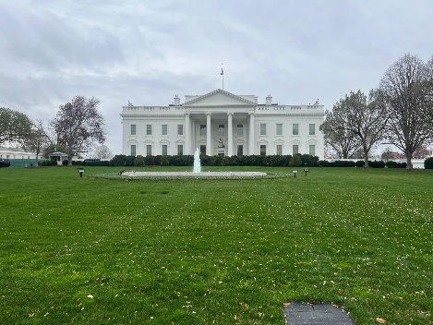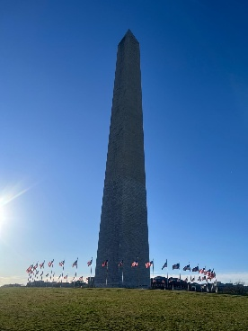

|  |
| --- |
| **Introduction:**  Include details of who you are, why you applied for this bursary and your experience of the event (maximum 100 words) |
| I work in hand therapy at band 7 level in a DGH. I applied for this bursary to enable me to have a once in a lifetime opportunity to attend an international conference.  It was a packed scheduled with the conference running from 7am to 6pm each day, so not much time for sightseeing! The packed conference schedule included surgeon and therapy symposiums, scientific paper sessions, joint therapy and surgeon sessions and instructional courses. Over 550 therapists plus surgeons from all over the world attended the conference so was a great networking opportunity. |
| **Title: “What have I learned and how will I put this into practice?”** The report will be uploaded onto the BAHT website and may be included in an e-bulletin. It should not contain any confidential information or any comments that are potentially damaging or libellous. It should be 500 words +/- 10%. |
| On day one, I attended a symposium on the skin which opened my thoughts about this organ, its many nociceptive and sensory/proprioception fibres and its impact on therapy. Of particular interest was the the use of k tape, which is having an increasing popularity in hand therapy treatment all over the world and I will certainly be utilising more in my own hand therapy practice. Following attending the peripheral nerve symposium I will now routinely use the scratch collapse test in my clinical practice and utilising taping of sensory nerves to aid treatment, using foam wedges and chip clips as utilised in Alison Taylors work.  The instructional course on CMMS has encouraged me to try this method on the stiff hand and I will deliver an IST on this to the team and introduce this technique in our hand therapy team. It seems negative to put the patient back in cast however the results can be life changing for the patient. I feel I now understand the rationale behind this method which has given me increased confidence to trial in my clinical practice,  I learnt some tips and tricks from the splinting symposium including the importance of sewing machines in hand therapy practice. Subsequently I have put in a charitable bid to get one for our department and have also made a pulley strap that was suggested for climbers that has been successful. The wound care instructional course provided me with dressing ideas to aid the healing processes in a variety of wounds.  The sessions delivered on carpal instability, DRUJ instability and hypermobility gave me some ideas for exercise programmes and will introduce these into the wrist class in the trust I work. The wrist stable orthosis was introduced for scapho-lunate instability which is unfortunately only available to buy in America but I’m planning on trying to reproduce this with thermoplastic and leather until it is readily available in the UK. Other sessions for example mallet injury/extensor tendons/hand fractures reinforced the guidelines/treatment strategies that I follow in my hand therapy practice are what others are doing internationally. I attended some surgical sessions which gave me valuable insights into the treatment of Kienbocks disease, the rheumatological wrist, the DRUJ and sports injury.  Finally, it was inspiring to hear from experts in the field of hand therapy and hand surgery including Dr Hagert discussing proprioception and Judy Colditz who delivered a keynote speech which has encouraged me to be innovative, curious and creative in my hand therapy practice. Mel Eissens also delivered a keynote speech on her epic row across the Atlantic and the effect on her hands, a truly inspiring journey.  I would like to thank BAHT for supporting me financially to attend this international conference it was an invaluable learning opportunity.  BAHT members at the comfernece…. |