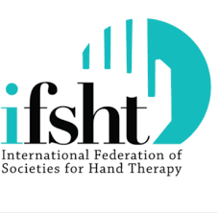
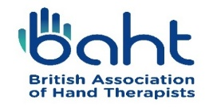
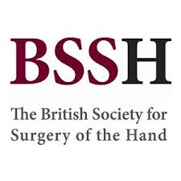

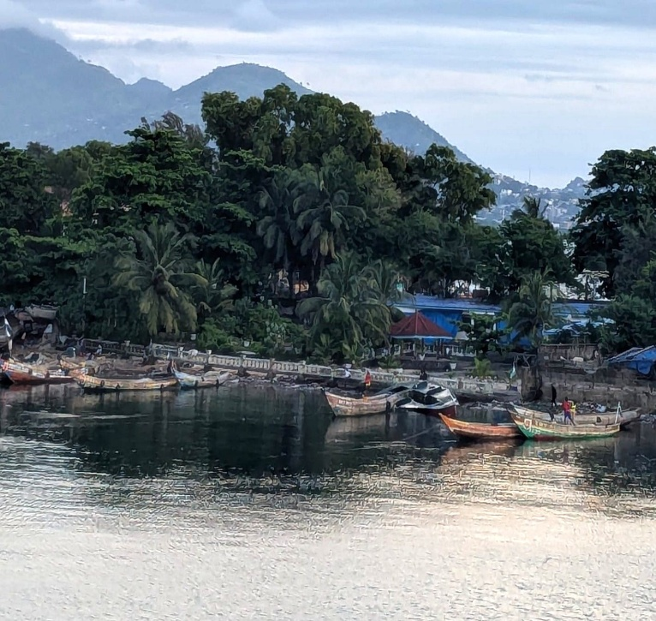
Inspiring perseverance and strength in training, empowering a strong foundation in knowledge, skills, and resilience to face challenges.

SIERRA LEONE
Knowledge shared,
Futures shaped

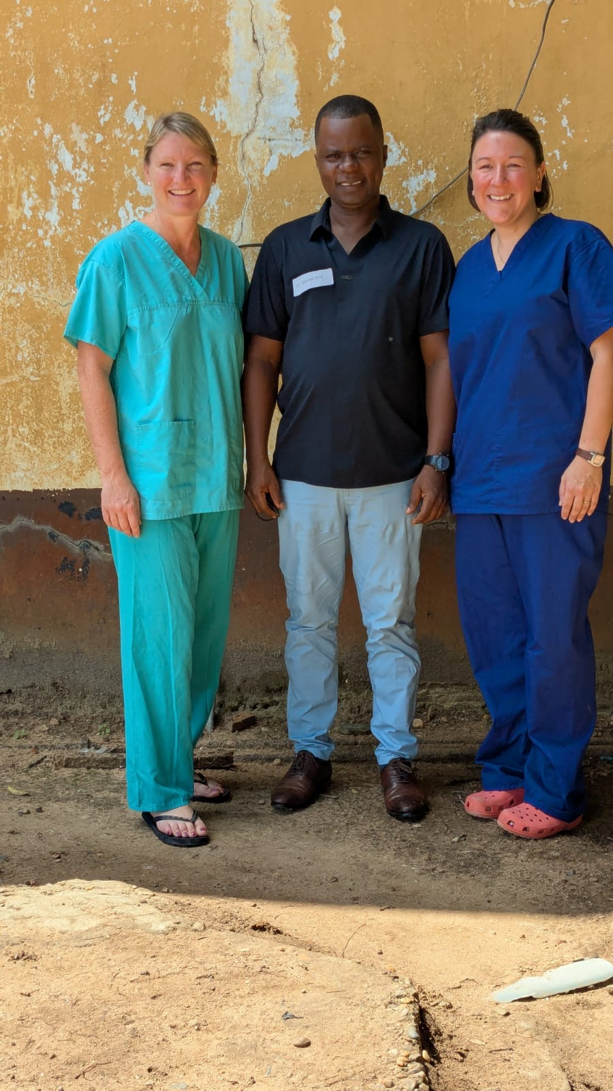
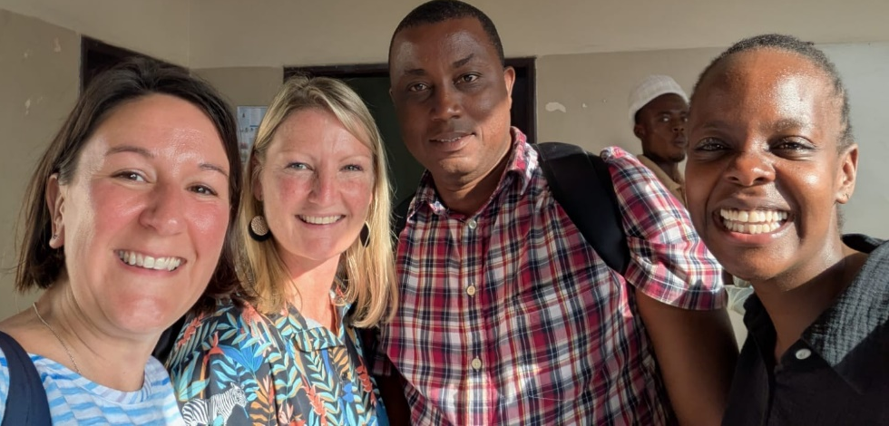
Aim of the Visit

The visit comprised of two teaching components and key activities included:

1. A collaborative two-day Hand Therapy Course to student physiotherapists at Tonkolili School of Health Sciences

2. An introduction to management of upper limb tendon and fracture injuries delivered to qualified physiotherapists and healthcare professionals currently managing upper limb injuries.

Sierra Leone Team Members

Mr Ismaila Kebbie, Deputy Director Mental Health and Non-communicable diseases, Ministry of Health and Sanitation and Head of Therapies, National Rehabilitation Centre.
Mr Jesse Banhuah, Lead Physiotherapist, Connaught Hospital Freetown.
Mr Abu Amara, Physiotherapist, Tonkolili District College of Health Sciences, President Sierra Leone Physiotherapy Association (SLPA)
Mr Balansama Janneh, Lead Physiotherapist, Holy Spirit Hospital, Makeni
Mr Ansu Kanja, Administration Physiotherapy, Tonkolili District College of Health Sciences
UK Team Members

Kirsty Doswell Hand Therapist Pascalle Smith Hand Therapist
Becky Chaplin Hand Therapist

Background
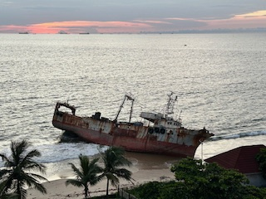
Sierra Leone is a low-income West African coastal nation of 7.6 million people, where 60% live below the poverty line. The healthcare system has been severely weakened by successive crises including civil war, the Ebola outbreak, and COVID-19 pandemic.
International partnerships have steadily strengthened Sierra Leone's healthcare capacity since 2010, The British Society for Surgery of the Hand (BSSH) and ReSurge Africa (NGO) have worked to develop Sierra Leone's first reconstruction unit, training local surgeons and a physiotherapist. Following civil war and Ebola, severe healthcare workforce shortages persisted—in 2019, only seven qualified physiotherapists served 7.6 million people. International collaboration through Masanga DK established a five-year Physiotherapy BSc and Diploma programme. The first cohort of 15 BSc graduates completed training in 2023, with 15 Diploma students graduating in December 2024. Complementing this formal education, teaching visits in 2023 and 2024 have provided targeted clinical training in hand therapy and upper limb rehabilitation to students, allied health professionals and qualified staff, building specialised expertise and supporting the development of sustainable, high-quality physiotherapy services across the country.
Planning
Pre-visit planning consisted of a UK team WhatsApp group, two team Zoom meetings and email communications. The therapy team met face to face for a course workshop and a practical planning session. All team members received a travel check list produced by Mike Waldram.
Communication with the Sierra Leone therapy leads and UK therapy lead were though WhatsApp and emails prior to the visit.

Reconstruction and Burns Unit Connaught Hospital
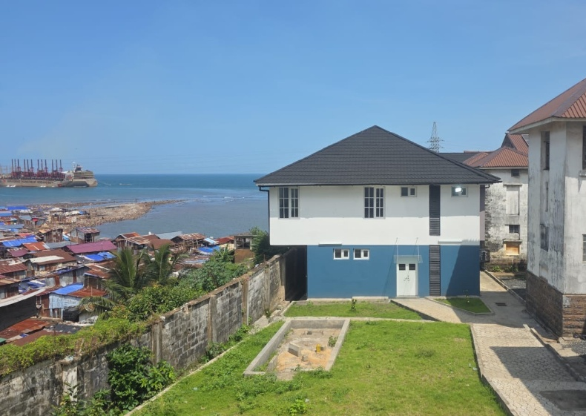
In 2021, a fuel tanker collision in Freetown caused a devastating explosion and fire, resulting in 153 deaths and 304 injuries. The city's medical infrastructure was overwhelmed, exposing critical deficiencies in burns care capacity.
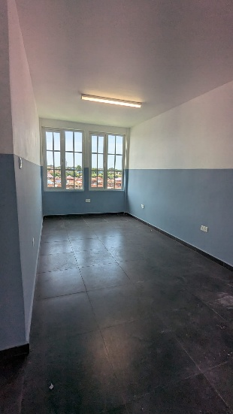
In response, BSSH, BAHT, and ReSurge Africa partnered with Connaught Hospital to develop Sierra Leone's first purpose-built plastics reconstruction and burns unit. During the 2024 visit, the newly constructed facility was toured and collaborative meetings held with hospital management to discuss operational protocols, staff training, and service implementation strategies.

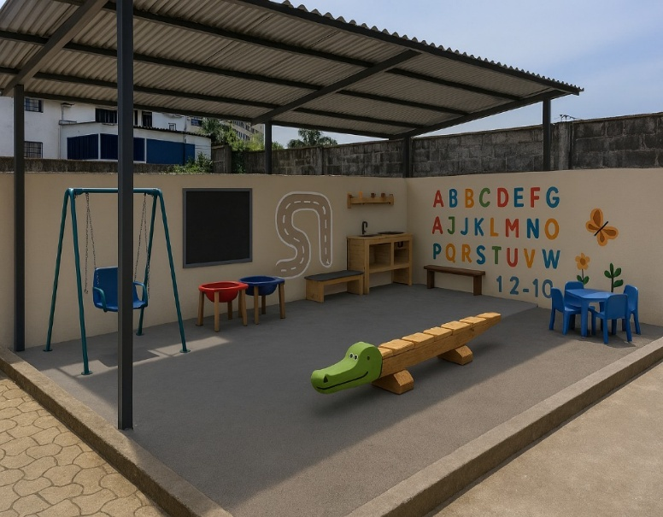
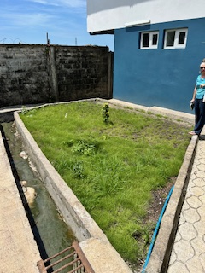
A particularly encouraging development is a separate, locally-funded project to create a therapeutic play area within the unit in collaboration with World Hope. Up to 80% of burns victims in Sierra Leone are children under five years old, this paediatric rehabilitation space represents both a clinical necessity and a significant achievement in local healthcare ownership. The initiative demonstrates community investment in holistic patient care and sustainable development beyond international support.

Tonkolili District College of Health Sciences, Masanga
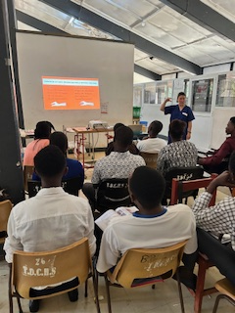
Tonkolili District College of Health Sciences, Masanga (three hours east of Freetown), trains healthcare professionals including physiotherapists. This third visit delivered an upper limb module to physiotherapy students, reaching a cumulative total of 62 students. Local lecturer Bala co-delivered lectures and facilitated workshops, demonstrating developing local teaching capacity.
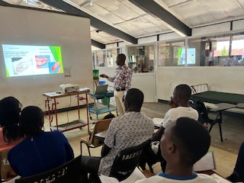

The two-day course was delivered to the 13 physios in their final year. College administration was efficient however the main teaching space was limited. However, it is worth noting for future trips that there was no air conditioning, limited lighting and no breakout rooms, making teaching uncomfortable.

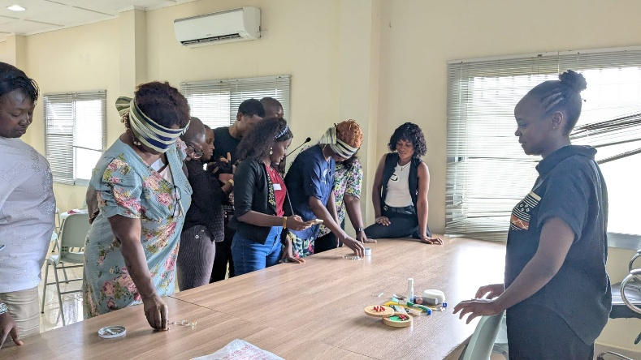
Choithram Memorial Hospital, Freetown
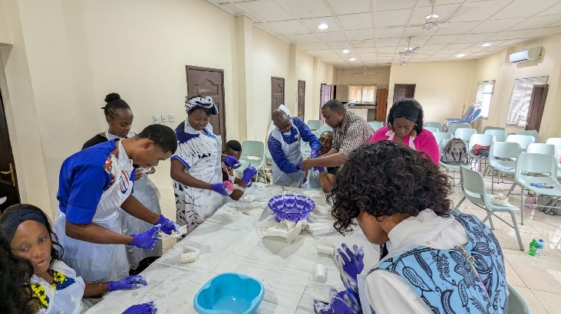
The second venue, Choithram Memorial Hospital in Freetown, hosted a two-day course on upper limb fracture and tendon injury management for 13 qualified physiotherapists and the country's sole occupational therapist. In partnership with local physiotherapist Jesse, who co-delivered lectures and facilitated workshops, the course benefited from excellent facilities and outstanding host support.
The course received official recognition from the Sierra Leone Physiotherapy Association (SLPA), awarding participants 13 CPD points applicable toward their biannual national registration requirements.
Evaluation
The two-day courses provided specialist upper limb therapy training to therapy students and qualified therapists. Significantly, local lecturers Jesse and Bala actively participated in course delivery and workshop facilitation, representing an important step toward local teaching capacity. Ongoing encouragement of college faculty and Sierra Leone Physiotherapy Association (SLPA) involvement remains a priority to achieve sustainable course ownership and eventual curriculum integration independent of international support.
The participants demonstrated exceptional engagement and eagerness to develop clinical assessment and intervention skills. Their enthusiasm is encouraging as they prepare to enter Sierra Leone's limited physiotherapy workforce. Continued collaboration can strengthen their knowledge base whilst fostering enduring UK-Sierra Leone mentoring partnerships.
Participant commitment was reflected in assessment results: pre- and post-course testing showed an average three-mark improvement, demonstrating measurable knowledge acquisition. Future course iterations could benefit from expanded content addressing specific conditions prevalent in local clinical contexts, preparing graduates for practice realities.
Course evaluation was incredibly positive about the delivery and content of the courses. All participants felt they had benefited from attending. Overall, 73% of attendees rated the course “Excellent”.
Feedback highlighted possible focus of upper limb conditions such as stroke, paediatrics and splinting more specifically as courses for therapists.
For both training programmes all teaching presentations, worksheets and a course workbook were presented to the local clinical and therapy leads for future use, access, and reference.

Moving Forward

Educational Programme Sustainability
Continued support of the Physiotherapy BSc/Diploma cohort develops upper limb knowledge and management from a therapist's perspective. Building on Jesse and Bala's expertise and local contextual understanding, they can confidently deliver course content, adapt to participant needs, and provide ongoing support. This transition empowers local faculty leadership, allowing the visiting team to step back whilst ensuring the programme remains impactful, culturally relevant, and sustainable.
Professional Association Partnership
Strengthening relationships with the Sierra Leone Physiotherapy Association (SLPA) remains essential for continued course recognition, professional standards development, and CPD provision. This partnership supports long-term sustainability and professional integration.
Connaught Hospital Reconstruction and Burns Unit Development
Collaborative development with Connaught Hospital's new unit presents significant capacity-building opportunities. Priorities include:
- Building specialised capacity among qualified physiotherapists
- Identifying training needs and addressing skill gaps
- Sourcing appropriate equipment and resources
- Developing a multidisciplinary allied health team
- Establishing physiotherapy and occupational therapy collaboration for comprehensive patient care

Support will be delivered through clinical mentoring, advisory roles in protocol development, resource sharing, and capacity building.
Occupational Therapy Development
Exploring recognition and training pathways for occupational therapy in Sierra Leone is critical. With only one qualified occupational therapist practicing nationally, priorities include establishing formal education programmes, professional recognition frameworks, and integration into healthcare teams—particularly within the reconstruction unit—to deliver comprehensive rehabilitation services.
I am very grateful to IFSHT, BSSH, BAHT and ReSurge Africa for making this training programme possible. Thanks also to all the team members involved for their ongoing fundraising, hard work, support, knowledge, and teamwork.
