BAHT Level II Course
Optimising Soft Tissue Function
Friday 21st – Sunday 23rd September 2018

Venue: Hand Therapy Department, Mount Vernon Hospital, Rickmansworth, Northwood, Middlesex, HA6 2RN
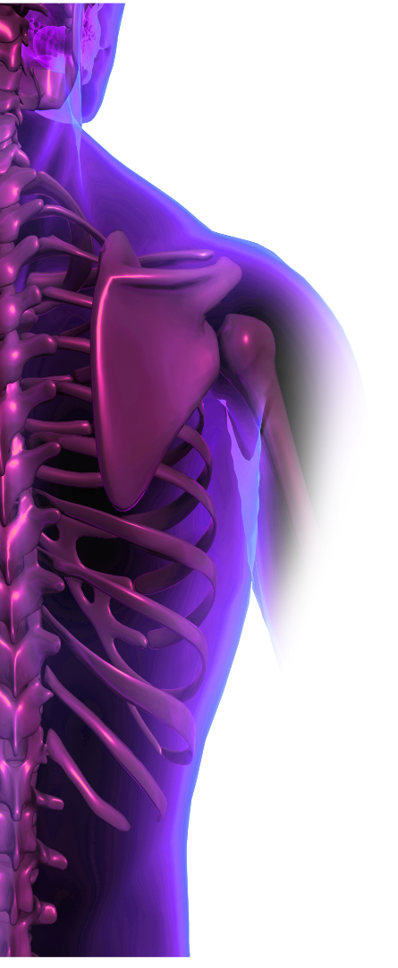
Key Note Speaker Day 1 & 2
Tim Watson PhD, BSc, MCSP, DipTP
Trained as a physiotherapist qualifying in the late 70’s. After spending a few years in the NHS (mainly out-patients & orthopaedics /rheumatology), Tim returned to the education sector to teach on various physiotherapy programmes. Currently Professor of Physiotherapy at the University of Hertfordshire teaching electrotherapy & tissue healing on the undergraduate & post graduate physiotherapy programmes and many other universities in the UK & internationally. Tim is a key opinion speaker of electrotherapy & soft tissue repair throughout the world

Course Organisers:
Nikki Burr (Lead Therapist – Hands & Upper Limb)
Ella Donnison (Senior Hand Occupational Therapist)

This BAHT level II course is open to therapists (OT or PT) working at Band 5 or above within the NHS or its equivalent outside it wishing to improve & develop an understanding of Tissue Repair & Pain Management from a Therapy Perspective.
Emphasis is given to enhancing the understanding of electrotherapy & the theory & practical application of ultrasound & TENS in optimising soft tissue function.
The application & evidence of other therapy modalities to optimise soft tissue function including massage (MEM) & traditional, dynamic & kinesiology taping will be addressed.
Practical sessions & workshops will cover an introduction to
taping (traditional, dynamic & kinesiology) & massage (MEM)
Practical competency elements are also included focussing on ultrasound & TENS.

The course will promote recognition of professional competence & will improve the quality of patient care.

There is an expectation that participants will have studied hand & upper limb anatomy in some detail prior to the course.

A reading list will be sent on booking confirmation.

BAHT Level II COURSE
Optimising Soft Tissue Function
Friday 21st – Sunday 23rd September 2018

COURSE FEE: £395-00
Includes refreshments & lunch, handouts, attendance certificate
Successful completion of full assessment process = BAHT level II points
Successful completion of practical assessments for ultrasound & TENS = certificate of competency

Cheques to be made payable to ‘Ella Donnison’

A PLACE WILL ONLY BE CONFIRMED ON RECEIPT OF THE COURSE FEE

CANCELLATION POLICY:
Cancellation: Substitution of delegates may be made at anytime, without cost, by informing the organisers. (Please notify Ella Donnison handtherapy@sky.com ASAP)

Cancellations must be received in writing/email.

A refund of the course fee will be made if you cancel your reservation EIGHT weeks prior to the date of the course booked. No refunds can be given after this date. Full refunds will be given if the organisers cancel the course.

Data Protection: Information concerning your registration is held on our database under the terms of the Data Protection Act 1998. The purpose for which this information is held is Direct Marketing, Education, Training and Administration. This information is not passed to third parties.
Completed application forms should be returned to:

Please complete clearly & return to:
BAHT level II Optimising Soft Tissue Function
16 Sabina Road
Papplewick Green
Hucknall
Notts
NG15 8JD

If your booking has not been confirmed within 14 days please call 07766554787 or email handtherapy@sky.com

Enquiries: Ella Donnison Tel No: 07766554787
E-Mail: handtherapy@sky.com

IF YOU ARE SENDING YOUR APPLICATION FORM VIA YOUR FINANCE DEPT
PLEASE ALSO SEND A COPY DIRECTLY TO US TO PROVISIONALLY RESERVE A PLACE

BAHT Level II Course
Optimising Soft Tissue Function
Friday 21st – Sunday 23rd September 2018

Venue: Hand Therapy Department, Mount Vernon Hospital, Rickmansworth, Northwood, Middlesex, HA6 2RN

PLEASE COMPLETE CLEARLY IN BLOCK CAPITALS
Surname: | First Name:
Job Title: | Length of time in Hands:
OT / Physio (please indicate)  Grade: | BAHT No:
Hospital Name: | Department:
Full hospital address: | Full Correspondence Address (if different):
Contact details:-  Tel: (Work) -  Tel: (Mobile / Home) - | Fax No:
E-mail address:

Please indicate any special dietary requirements: | Please indicate any special educational needs:
How did you hear about this course?

COURSE FEE: (Cheques to be made payable to ‘Ella Donnison’)

BAHT Level II £395.00

Booking Confirmation will be sent on receipt of Payment

