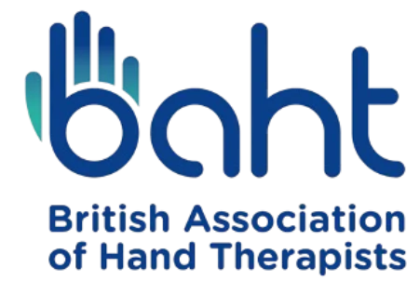 AHT Mentoring Programme
Mentee Request Form
Please complete this short form to be matched with an AHT mentor. All information will be treated in confidence. Return to AHT Coordinator baht.aht@gmail.com

1. Your Details

Full name

Email address

Primary place of work

BAHT membership number
2. Your Clinical Background

What is your primary clinical role?
□ Occupational Therapist | □ Physiotherapist
□ Other (please specify below)

If other, please specify

How many years have you been working in hand therapy?
□ Less than 2 years | □ 2–5 years
□ 5–10 years | □ More than 10 years

What are your main areas of clinical interest or speciality? (tick all that apply)
□ Trauma and fractures | □ Tendon injuries
□ Nerve injuries | □ Arthritis and joint conditions
□ Peripheral nerve conditions | □ Dupuytren’s disease
□ Paediatrics | □ Burns and reconstructive
□ Acquired conditions  □ Other (please specify below) | □ MSK  □ Arthritis/ joint conditions

If other, please specify
3. Your AHT Application

Where are you in the AHT application process?
□ Just starting to consider applying | □ I’ve read the guidance and ready to begin
□ Already started gathering evidence | □ Well underway but need support

How confident do you feel about the AHT application process overall?
 | 1 Not at all confident | 2 | 3 | 4 | 5 Very confident

What aspects of the application are you most uncertain or concerned about? (tick all that apply)
□ Understanding the criteria | □ Gathering suitable evidence
□ CPD documentation | □ Reflective writing
□ Portfolio/CV structure and presentation | □ Time management
□ Other (please specify below)

If other, please specify

Are there any specific areas you would particularly like your mentor to help with?

4. Practicalities

Do you have a preference for how you meet with your mentor?
□ Online (virtual meetings) | □ Face-to-face (within my local area)
□ No preference - either suits me

If you would prefer face-to-face meetings, please indicate your location so we can try to match you with a mentor in your area. Please note that face-to-face matching may not always be possible.
Location / region (if face-to-face preferred)

Is there anything else you’d like us to know when matching you with a mentor?
Declaration
I confirm I am a current BAHT member and understand that the AHT mentoring programme is a supportive resource. I take responsibility for driving my own application forward.
I understand and agree that the information provided in this form will be held securely by BAHT and used solely for the purpose of matching me with an appropriate mentor. This data will be processed in accordance with the UK General Data Protection Regulation (UK GDPR) and BAHT’s privacy policy. My details will be shared with my allocated mentor only and will not be disclosed to any third party without my consent. I may request access to my data or ask for it to be removed at any time by contacting the AHT Coordinator.
I understand that all discussions with my mentor are confidential, and I will likewise treat any information shared by my mentor in confidence. Any patient information I discuss during mentoring sessions will be appropriately anonymised in accordance with professional and legal obligations.
Applicant signature | Date
Please return this form to the AHT Coordinator via Baht.aht@gmail.com
BAHT website: www.hand-therapy.co.uk British Association of Hand Therapists • Supporting Excellence in Hand Therapy

