Application to run a BAHT Level II validated course

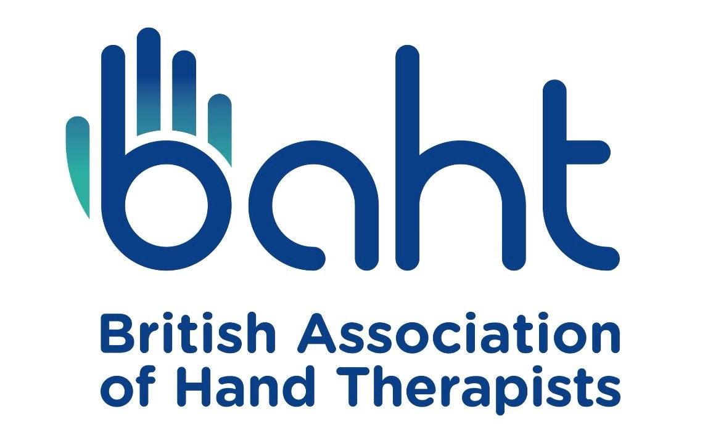

British Association of Hand Therapists (BAHT)

Level II Course
Application form

Revised April 2026 Version 8

This document replaces all previous versions.

Provider Details
Name(s):

Postal address:

Phone Number:

E-mail:

BAHT Membership Number(s):

Course Details (for advert on BAHT website)
Course title:

Course dates:

Course venue/location:

Course fees: Standard (non-member BAHT); £
BAHT member (minimum 10% discount from standard); £
Other (e.g. early bird discounts if applicable); £
Details:

Contact name(s):

Contact email address(es):

Contact phone number(s):

Is lunch to be included in the course fee?: Yes/No
NB if lunch is not to be included it is expected this would be reflected in the delegate fee. Refreshments during tea/coffee breaks should be provided as standard on all BAHT validated courses.
Any other brief information for website advert:

If you would like your course flyer, registration form or any other relevant documents uploaded onto the BAHT website alongside your course advert please provide a copy with your application.

Other required information
Brief CVs of all course organisers/contributors and proposed speakers enclosed ☐
Proposed Course programme: enclosed ☐
will be forwarded by minimum 6 months prior to course dates ☐ (NB course cannot be validated without programme).

Named person who will contact/liaise with BAHT representative regarding the course:

Planned maximum number of attendees:

Details of facilities at course venue (e.g. appropriate lecture/workshop/refreshment spaces, wheelchair accessibility, etc.

Application fee
Please note that payment of the £150 course application fee must be made before an application can be considered or the course advertised on the BAHT website. We are no longer able to accept cheque payment for course fees so please provide relevant details for invoicing below:

Invoice addressee name
Contact e-mail address
Contact phone number
Postal address
PO number (if applicable)*
*If a purchase order is required, please ensure this is raised prior to submitting this application and quote the relevant number here. Please contact us if you have any queries regarding this via baht.escfinance@gmail.com

To avoid unnecessary delays in processing your application and advertising your course, please ensure you notify the committee (baht.escfinance@gmail.com and copy in baht.level2@gmail.com) when you make payment. Receipts will not routinely be provided, please notify us if this is something you specifically require.

Please return your completed form to baht.level2@gmail.com

For office use only
Date application received:

If all relevant sections of form are complete, forward to baht.escfinance@gmail.com so that invoice can be raised, following confirmation of payment forward details to bahthandtherapy@gmail.com for advertisement (cc. course provider).

If any sections of form are incomplete, please return to sender to complete and return.

