BRITISH ASSOCIATION OF HAND THERAPISTS

LEVEL III

Hand Therapy Journal Article Publication

Application Form

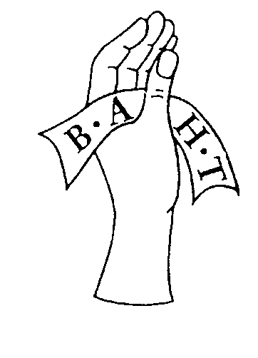

Revised March 2018

Copyright British Association of Hand Therapists May 2000
This Document Replaces All Previous Documents

British Association of Hand Therapists
Level III Statement of Ownership
Appendix 1

Plagiarism is intellectual theft & is a serious form of cheating. It is the act of presenting as one’s own, the ideas (including images & designs), discoveries or judgements of another person. To copy extracts without full acknowledgement (whatever the medium in which the text or image is stored), from someone else’s work & to thereby convey the impression that they are one’s own is plagiarism. So is the paraphrasing – restating in one’s own words – of someone else’s ideas without full acknowledgement. We all utilise the ideas of others; we have a most serious obligation to acknowledge them meticulously.

Plagiarism
A declaration of academic integrity

“I have read & understood the regulations on plagiarism & the work submitted is my own”

Signed: ____________________________________ Date: ______________

Candidates Name: ___________________________

Name of Candidate: BAHT Membership number:
Appendix 2 – Application for Level III points after publication of an article in Hand Therapy Journal
Contact e-mail:
Contact address:

Title of published article:

Date of Publication*:
*Only articles published within the 12 months prior to application being made to the ESC can be considered for Level III BAHT Points.

Previously Acquired BAHT Accreditation Points
 | Course / Accreditation of Prior Learning (APL)  Title & Venue | Date
Level I
Level II
Level II
Level II
Others

Application for Level III points after publication of an article in Hand Therapy Journal – Checklist
- Application form completed
- CV
- Statement of ownership (appendix 1) completed
- Copy of published article
- Payment of £30 (cheque made payable to BAHT)

Please send electronic copy of your application & all required documents to: baht.level3@gmail.com
Please send a paper copy of your application & all required document including cheque payment to the BAHT Secretary Address: BAHT, PO Box 304, WOODBRIDGE, IP12 9EX

I confirm that the article I am submitting is entirely my own work & I request that it be considered for 5 BAHT Level III points.

Signed: _______________________________ Date:

Or

I confirm that the article I am submitting as co-author is 50% my own work & I request that it be considered for 2 ½ BAHT Level III points.

Signed: ________________________________ Date:

Counter signed*:_______________________ Name: _________________________
*Counter signature must be that of co-author to confirm their agreement that applicant was responsible for 50% of the work for article. If both authors wish to submit an application for BAHT points each should use a separate application form.

