BRITISH ASSOCIATION OF HAND THERAPISTS

LEVEL III

MSc Module Application Form

(You DO NOT require these guidelines if you are completing the Nottingham University MSc Injection therapy module, Brunel MSc Hand Therapy Module or Ulster MSc Hand Therapy module)

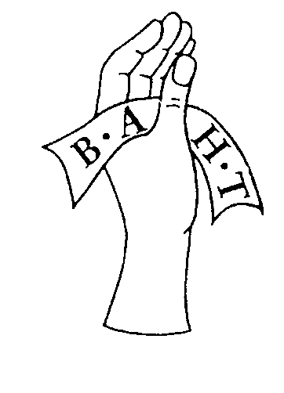

Revised February 2017

Copyright British Association of Hand Therapists May 2000
This Document Replaces All Previous Documents

Appendix 1 – Application for Level III points on completion of a non-accredited MSc module

Name of Candidate:

BAHT Membership number:

Contact e-mail:

Contact address:

University/Institution of Study:

Title of module proposed for conversion to Level III accreditation:

Title of assignment completed for module (note: this must be related to hand/upper limb therapy).

Please complete this form & tick checklist to ensure you have included all the information required. Return this both electronically & by post to the BAHT Secretary accompanied. Payment must be included before the ESC can consider your application.

£30 application fee (cheque made payable to BAHT) postal only.

Module completed credits 20 or more.

Breakdown of module (this should be available from your university) i.e. programme, content, time scales.

Breakdown of module assessment process (this should be available from your university).

Evidence of successful completion of module (copy of certificate – please do not send your original as documents cannot be returned).

Abstract of assignment & 400 to 500 word reflection detailing how this module has enhanced your learning & development as a hand/upper limb therapist, & influenced your practice. Note: please do not exceed this limit, anything over 500 words will not be considered as part of the application.

Previously Acquired BAHT Accreditation Points
 | Course / Accreditation of Prior Learning (APL)  Title & Venue | Date
Level I
Level II
Level II
Level II
Others

Signature of candidate*:________________________________ Date:____________

