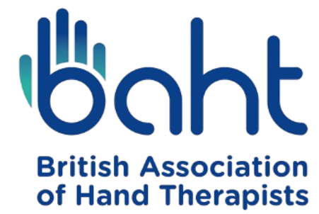

Photo and Video Consent Form for patient/child or staff/volunteer

It is recommended that a translation of this form be devised with a local representative from the local team to ensure transparency with agreeing participants. Where illiterate parties are involved the agreement will be verbally agreed upon and specified as such.
The British Association of Hand Therapists (BAHT) kindly requests your consent to take photographs and/or video recordings of you or your child. These materials may be used to support education, professional awareness, fundraising, and promotional activities in both printed and digital formats.
Please tick the boxes below to indicate your agreement:
☐ I consent to BAHT, or individuals authorised by BAHT, capturing photographs and/or video of me/my child.
☐ I agree that these images or recordings may be used by BAHT for approved purposes including, but not limited to, educational resources, presentations, printed publications, websites, social media, and other communications.
By providing this consent, I understand that:
- Any personal data will be processed and stored in line with UK GDPR and relevant data protection legislation.
- My name may be included alongside the images or recordings where appropriate.
- Copyright of the images and recordings will belong to BAHT and/or the photographer/videographer, and the materials may be edited, adapted, or combined with other content.
- I may withdraw my consent at any time by contacting BAHT (see email contact below). This will prevent future use, but will not affect materials already published or in circulation.
- I understand that no payment or other compensation will be provided for my participation.
Further details on how BAHT manages personal information can be found in the BAHT Privacy Policy.
If you wish to have any images removed please contact the Global Partnerships Committee @:
baht.gpcsecretary@gmail.com

Name of patient / participant:

Name of parent / guardian (if participant is under 16):

Signature (participant or parent / guardian):
Date:

For BAHT Use Only
This form records consent for images, video or related contributions to be used across BAHT platforms, including print, online and social media. BAHT is committed to ensuring all content is used respectfully and appropriately.
Location where images/videos were taken:

Individuals involved (including staff):

